Twilight Core

Contents

Functional specification 2

Style of the game 2

Player mechanics 2

Combat 2

Core 2

Focus Mode 2

Ideas 3

Setting 3

Premise 3

INTRO 3

Plot 4

Stages 5

1 - Asura’s Path 5

2 - The Black Forest 5

3 - Riverbank 6

Lotus Garden 6

Hindu Temple 6

Temple Courtyard 6

Characters 7

Player Character: Soma 7

Boss 0.5 - Asura 8

Boss 1 - Maaya, Forest Guardian 8

Boss 2 – Joanette, the Spider Queen 9

Boss 4 – Lakshmi 10

Mechanics 11

Player 11

Score system 11

Controls 11

Development 12

Goals for 0.1.0 (2016) 12

Goals for 0.2.0 (2022) 12

Goals for 0.3.0 (2022) 12

In development 0.3 13

UNITY NOTES 14

0.3 (2022) 15

# Functional specification

## Style of the game

This game is a danmaku (bullet curtain shoot 'em up) game. Much of the gameplay relies on surviving a curtain of bullets shot by waves of enemies while powering up the character by collecting various points left by shot enemies. Additionally the player's weapons (Day Core & Night Core) can be upgraded to improve basic attributes and the damage done by their special attacks (bombs). Every stage features many enemy waves, often interrupted by a mid-boss with more complex patterns and the stage ends with a boss-battle with many bars of hit points to deplete and many phases of different bullet curtain patterns.

## Player mechanics

### Combat

Player is able to continuously shoot upwards approx. 10 bullets per second

### Core

Core is a weapon that has passive abilities (shooting power and score multiplication) and an active ability (bomb). When the bomb is used or the player is hit the Core bar depletes and the Core powers down.

### Focus Mode

Changes the core in use from Day Core to Night Core and the passive abilities that come with the core (magnetic point collection, slower movement speed for accurate dodging)

# Ideas

## Setting

The setting heavily relies on Hindu/Vedic mythology and Indian cultural motifs. The story is constructed on top of stories from Hindu/Vedic mythology with a creative variation here and there. The narrative is from the main character's perspective as she journeys through the undiscovered realm.

## Premise

Every world has its own Chandra, a guardian of its solar rhythm. Soma is a Chandra of this world, tasked to guard the Day, Night, and Twilight Cores, all responsible for the phases of the day. Soma is also an avid pumpkin farmer and developed the hobby to battle her daily monotony. One day she thought “I wonder if my pumpkins grew a bit fatter if the day lasted just a tiny bit longer” and decided not to activate the Twilight Core that night. To activate a core, she needs to hold it to its pedestal for a moment and the phase of the day changes. After she’s done, she puts the cores into her hat. As the sun was to set, she was measuring her pumpkins on her yard. She feared that reality would break but alas, it didn’t. As she was crawling on the ground her hat fell off and the Twilight Core rolled out. Suddenly an Asura appeared from the woods and snatched the core, and ran off. Soma screamed and grabbed her broom in pursuit, planning to use the Day and Night cores to defeat the Asura.

### INTRO

“Any world that rotates, gets their own guardian, a Chandra.”

“The solar rhythm of this world has been trusted to a young Chandra named Soma.”

“To battle the daily monotony of maintaining the Cores she picked up a hobby: growing pumpkins, overly obsessing over their size and quality.”

“One day she thought it was a good idea to see if they grow a little larger if only the day lasted a little longer…”

“The cores of Day and Night in her hat stayed intact when she crawled in the patch and dropped her hat.”

“But the Twilight Core was stolen by quick hands…”

## Plot

The Lordess of the realm of Asuras has opened pathways to the regular world and sent Asuras to fetch her a mystical item, “The Twilight Core”. But by removing it, the world stopped seeing sunrises or sunsets, only perpetual night or day.

You are Soma, a happy-go-lucky witch, a pumpkin farm owner who loses her Twilight Core to a thieving asura.

Soma tracks the Asura who stole the core and follows its path to a forest that is guarded by Maaya, a Friendly Huldra.

After defeating her, Soma travels deep into The Black Forest where Joanette, the Queen of Spiders is helping the Asuras open pathways between worlds. Soma defeats her and follows the Asura through the pathway.

In the Asura realm Soma is flung to a river from the portal. After shaking herself dry she follows the riverbank and catches up to the asura who tries to use the core against her again. She chases it away and meets (Boss3), a commander of the asuras.

Soma enters a lotus garden of the (Boss6) temple where she meets (Boss4/Lakshmi).

Stage 5 signifies the various layers of the temple (Asura, Human, Deva, Brahma). Soma makes her way to the middle and meets (Brahma) who’s given (Boss6) a boon that makes her immortal. (Brahma) doesn’t think Soma is suitable to mess with deity business so she has to defeat her.

After proving (Brahma) wrong she teleports Soma to an astral plane, a courtyard beyond the temple. Soma lures out (Boss6). After Soma survives her initial attacks, an avatar appears and knocks the core out of (Boss6)’s hand, and Soma catches it. (Boss6) is now vulnerable and using the Twilight Core Soma is able to defeat her.

Afterwards Soma returns to her realm to enjoy the sunsets and sunrises again.

## Stages

1 - Asura’s Path

*BGM - “Asura who remain Asura”*

Soma follows an asura that has stolen the Twilight Core. After pursuing him for a while, dodging all the gandharvas that are adamant to stop her advance, she encounters the boss of the gandharvas who has been asked by the spider queen to let no one enter the forest while her rites are on.

* Boss 0.5: Asura
* Boss 1: Maaya, Forest Guardian (Fox Gandharva)

#### Environment

Fields, pumpkins and a fenced road with trees on the side. Sunny day

#### Enemies

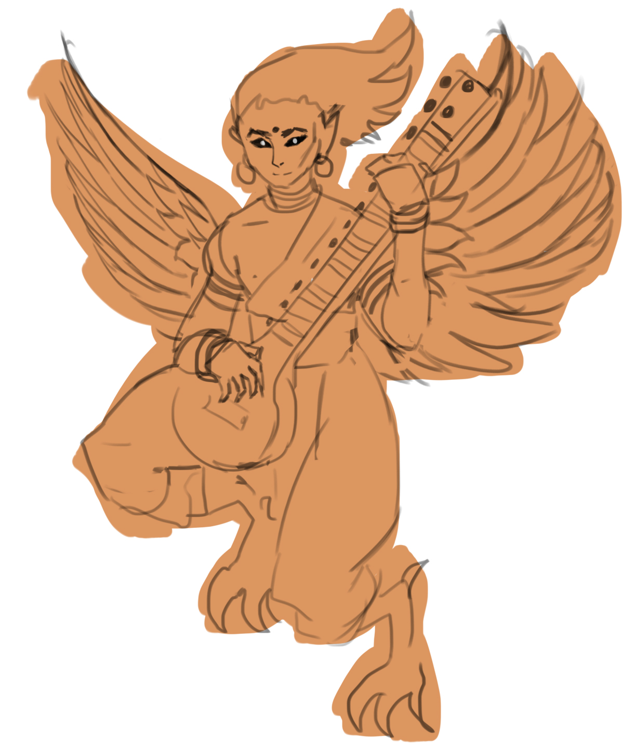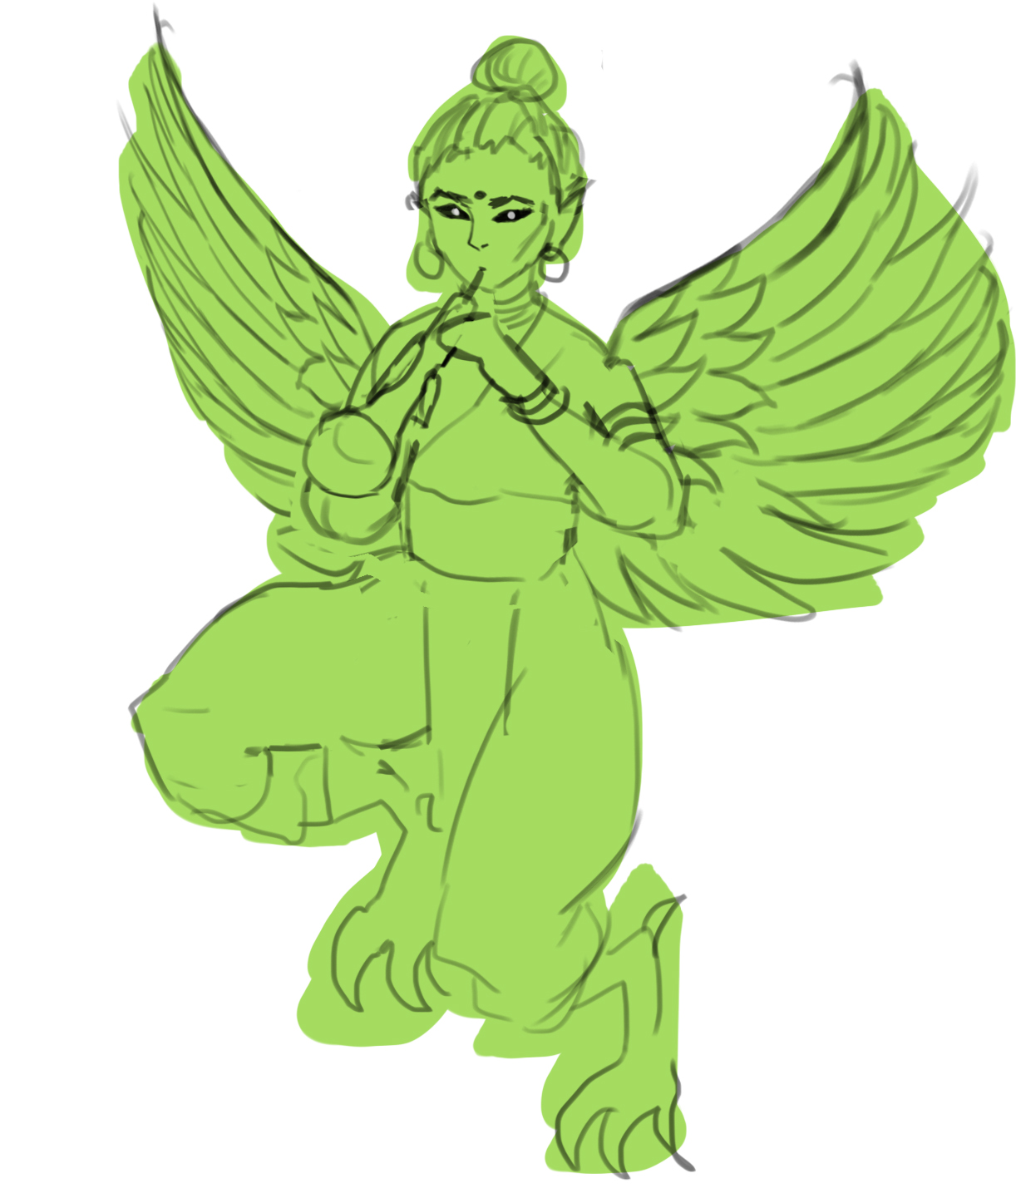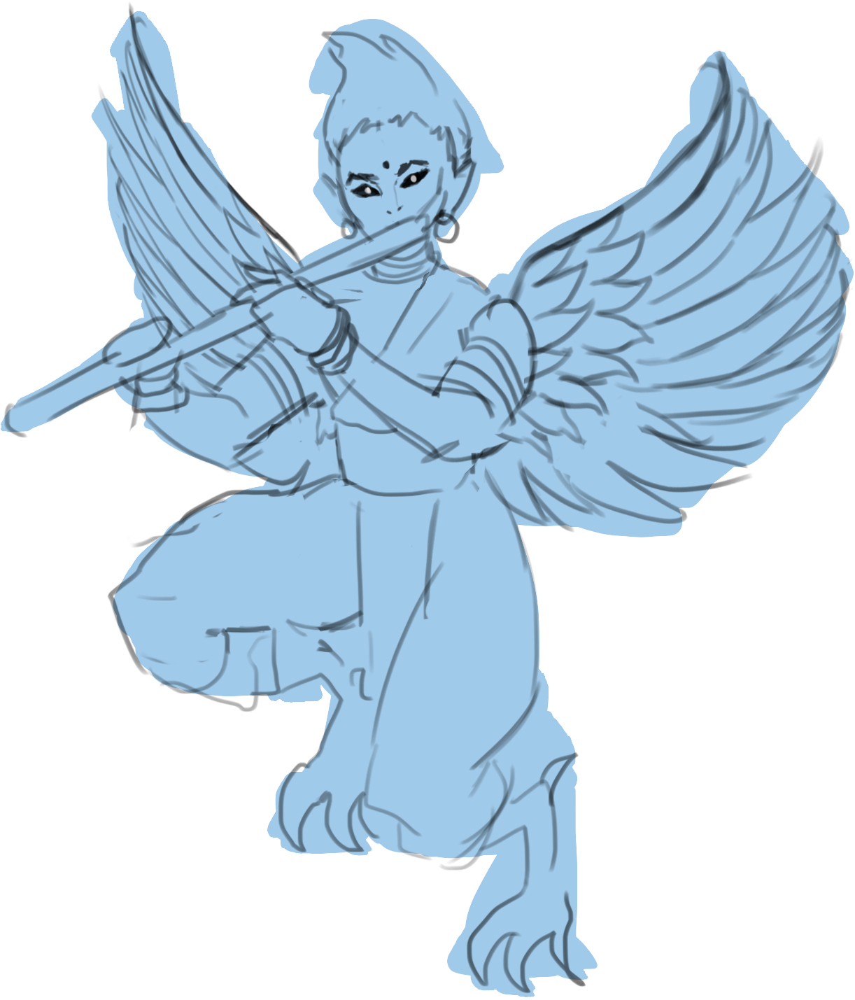

Forest Guardian’s minions, various Gandharvas. **Reoccurring enemies throughout the game.**

*Some are part animal, usually a bird or horse and are connected with trees and flowers. They have superb musical skills, guarded the Soma and made beautiful music for the gods in their palaces. Gandharvas are frequently depicted as singers in the court of Gods and act as messengers between the gods and humans.*

**Art:** Wings, animal feet, different instruments (sitar, flute, shehnai). Different colored garments by instrument. Sprite has flapping wings

**Bullet ideas:** Leaves, flowers, musical notes

2 - The Black Forest

*BGM - “Spelunker”*

Soma proceeds to the forest when she notices a twilight leak. She follows it deeper to the forest where she meets a Spider Queen who is opening portals to the asura’s realm. She defeats her and travels through a portal.

#### Environment

Thick woods, red lights between. Dark lighting

#### Enemies

Some gandharvas, Spider Queen’s squires

* Midboss: ??
* Boss: Spider queen
  + BGM: Void Dance

3 - Riverbank???

* Midboss: Asura
* General of asuras

Lotus Garden4th stage and boss? Asura

* Boss: Lakshmi

Hindu TempleMain character meets (Brahma) who’s given the final boss a boon that makes her immortal. (Brahma) doesn’t think the main character is suitable to mess with deity business so she has to defeat her. After defeating (Brahma) main character acquires a power from her to temporarily change day or night to twilight to kill the final boss. (Twilight Core)

* Boss: (Brahma)

### Temple Courtyard

## Characters

### Player Character: Soma

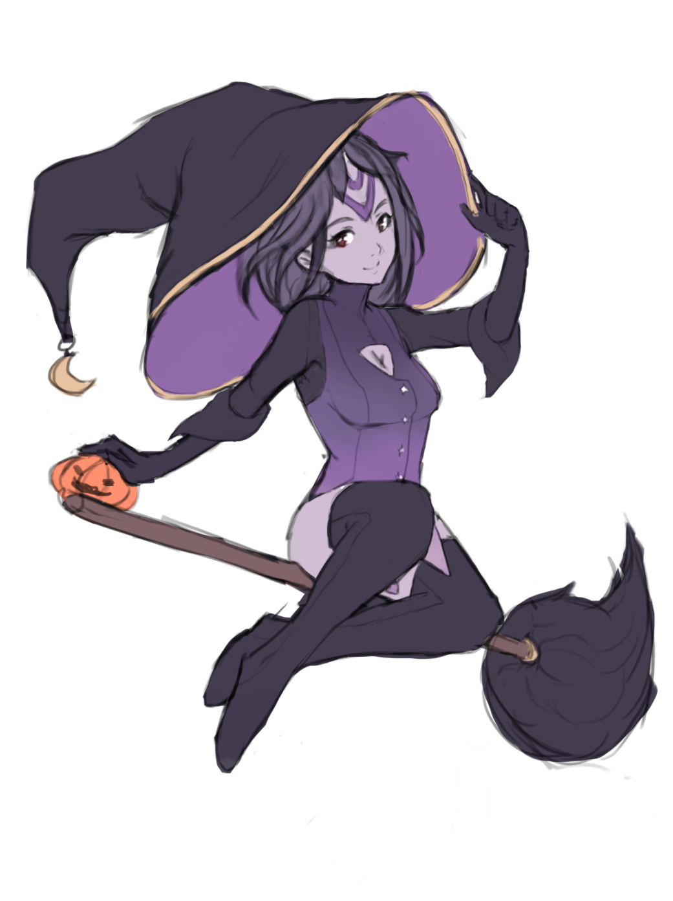

Every world has a guardian of its solar rhythm. Soma is tasked to guard the Day, Night, and Twilight Cores of this world, all responsible for the phases of the day. Soma is also an avid pumpkin farmer and developed the hobby to battle her daily monotony. The story starts when she loses the Twilight Core to a thief and is desperate to get it back to restore the balance of the world.

### Boss 0.5 - Asura

* Special: Twilight Core: Depulsio
* *"Asuras who remain Asura" share the character of powerful beings obsessed with their craving for ill-gotten Soma, and for wealth, ego, anger, unprincipled nature, force, and violence. Further, in Hindu mythology, when they lose, miss, or don't get what they want (because they were distracted by their cravings) the "Asuras who remain Asuras" question, challenge, and attack the "Asuras who became Devas" to loot or extract a portion of what the Devas have and the Asuras do not.*

### Boss 1 - Maaya, Forest Guardian



* BGM: “Sweet Trickster”
* *Māyā connotes a "magic show, an illusion where things appear to be present but are not what they seem"*
  + She pretends to be a human but is a fox. But her tail gives her away. Huldras are usually said to be very self-conscious about their tail and back, and attacks anyone who points them out.
* Boss of the gandharvas of the area
* Spear
* Spell idea: spiral spears
* hard to catch, teleportation
* fox fires: slow cluster bullets

### Boss 2 – Joanette, the Spider Queen

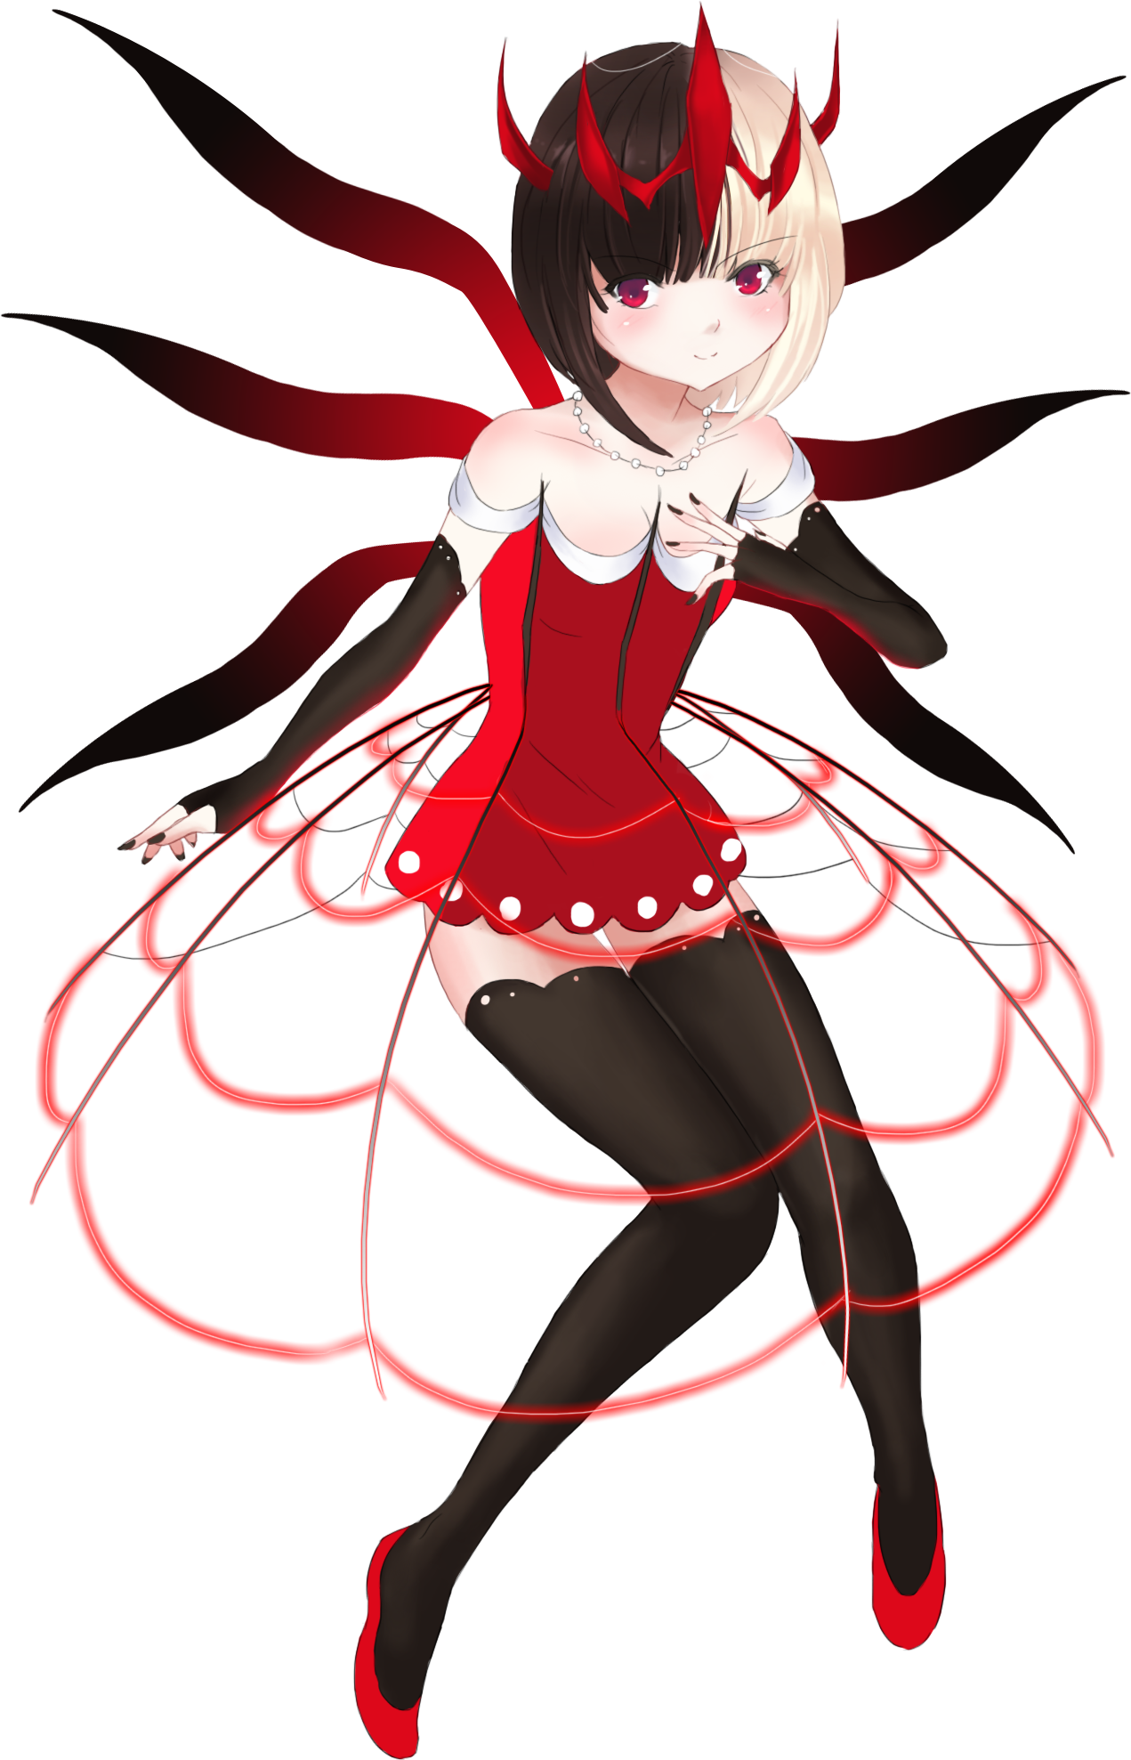

"In the Vedic philosophy of India, the spider is depicted as hiding the ultimate reality with the veils of illusion.”

“Indra's net is used as a metaphor for the Buddhist concept of interpenetration, which holds that all phenomena are intimately connected. Indra's net has a multifaceted jewel at each vertex, and each jewel is reflected in all of the other jewels”

“In some schools of Buddhism and in Hinduism, the image of Indra's net is a metaphor for the emptiness of all things, and at the same time a metaphor for the understanding of the universe as a web of connections and interdependence”

“If a person comes into contact with a Live spider by default, he or she will get new clothes as per local belief in Hindu customs.”

Spider Queen is opening portals to the asura world, symbolizing Indra’s Net and its connectivity.

* Basic phase 1: small web clusters, homing arrows, spiders
* Basic phase 2: shoot laser webs, slow spider bullets
* Spell 1: Indra’s Net
  + Maelstrom spiral + Giant spiderweb with big rotating bullets spawned in a circle
* Final spell: Void Dance
  + Starts opening a white void behind her (serving as the portal the player goes through to the next level)
  + Otherworldly bullets come out of the void while boss shoots homing bullets the player has to dodge rhythmically

## Boss 3 – Danu

## https://static.wikia.nocookie.net/mythology/images/1/19/Dewi_Danu.jpg/revision/latest/scale-to-width-down/1000?cb=20200707023219

* *BGM: ”Mother’s Fears, Mother’s Tears”*
* दानुः As a word for "rain" or "liquid", dānu is compared to Avestan dānu, "river"
* The mother of the thieving Asura
* Mourns her son Vrtra, slain by Indra. Wants to stop Soma from pursuing her children
* Water patterns: Rain, tears, riverwater

**Pattern ideas:**

* Falling rain
* Accelerating Tear clusters
* A river flow (negative space?)
* Asura bodyguards (killable, which intensifies the pattern?)
* Water Bullets accumulate on the bottom of the screen
  + Probs needs bullets to be changed into rb2d
* Summon Rewa from the Narmada River
* [SPELL] ”Mother’s Fear: Loss” Total darkness uncounting the immediate area around the player
* [SPELL] ”Mother’s Fear: Death”

### 

### Boss 4 – Saraswati/Lakshmi/Parvati Tridevi

### https://upload.wikimedia.org/wikipedia/commons/1/12/Saraswati.jpg https://upload.wikimedia.org/wikipedia/commons/a/a6/Raja_Ravi_Varma%2C_Goddess_Lakshmi%2C_1896.jpg https://upload.wikimedia.org/wikipedia/commons/3/32/Goddess_Parvati_and_her_son_Ganesha.jpg

* 4-phased boss with each phase representing one facet of the Tridevi and the last one their ultimate form, Lalita
* *Tridevi goddesses are given the eminent roles of Creator (Mahasaraswati), Preserver (Mahalakshmi), and Destroyer (Mahakali)*
* PHASE 1: Saraswati सरस् (knowledge that purifies) is the goddess of learning, arts, and cultural fulfillment. A beautiful woman dressed in pure white, often seated on a white lotus, which symbolizes light, knowledge and truth. Holds a pustaka (book or script), a mālā (rosary, garland)
  + Pattern ideas:
  + [SPELL] “Avatar: Vidya” विद्या the formless concept of wisdom and knowledge in all of its aspects. Cosmic intelligence, cosmic consciousness, and cosmic knowledge.
* PHASE 2: Lakshmi लक्ष्मी is the goddess of wealth, fertility, auspiciousness, light, and material and spiritual fulfillment, prosperity, glory, magnificence, joy, exaltation, and greatness, and spiritual fulfillment. An elegantly dressed, prosperity-showering golden-coloured woman standing or sitting in the padmasana position upon a lotus throne, while holding a lotus in her hand, symbolising fortune, self-knowledge, and spiritual liberation
  + Lakshmi is very often shown with one or two elephants, and occasionally with an owl. Elephants symbolize work, activity, and strength. The owl signifies the patient striving to observe, see, and discover knowledge, particularly when surrounded by darkness. As a bird reputedly blinded by daylight, the owl also serves as a symbolic reminder to refrain from blindness and greed after knowledge and wealth have been acquired
  + Pattern ideas:
  + [SPELL] “Avatar: Gayatri” गायत्री is the personified form of the Gayatri Mantra, a popular hymn from Vedic texts.
* PHASE 3: Parvati पार्वती is the Hindu goddess of power, nourishment, harmony, devotion, and motherhood. She is a physical representation of Devi in her complete form
  + Parvati, the gentle aspect of Devi Shakti, is usually represented as fair, beautiful, and benevolent. She typically wears a red dress (often a sari), and may have a head-band
  + Hands may hold a trident, mirror, rosary, bell, dish, goad, sugarcane stalk, or flowers (such as a lotus)
  + The Puranas tell the tale of Sati's marriage to Shiva against her father Daksha's wishes. Daksha does not invite Shiva to his yagna. Sati comes on her own and immolates herself at the ceremony. This shocks Shiva, who isolates himself in the mountains. Sati is then reborn as Parvati, "she from the mountains"
  + [SPELL] “Avatar: Mahakali” महाकाली is the Hindu Goddess of destruction and doomsday. Mahakali is fiercest of the Goddesses of universal power, time, life, death and both rebirth and liberation. She devours Kala (Time) and then resumes her own dark formlessness. She is also the consort of Mahakala, the god of consciousness, the basis of reality and existence. Mahakali in Sanskrit is etymologically the feminized variant of Mahakala or Great Time (which is interpreted also as Death), an epithet of the god Narasimha or Shiva in Hinduism.
  + According to Lalitopakhyana of Brahmanda Mahapurana, Parvati, Lakshmi, and Saraswati are the three incarnations of Lalita
* Phase + spell per devi +Final form Lalita?

# Mechanics

## Player

* Day / night core meter
* Day Core: Starlight special
  + Star bombs explode in different places, destroying enemies and bullets
* Night Core: Trick or treat
  + Pumpkin shaped field consumes all bullets around player
* Add life gen points? or just extra lives
* Both cores deplete if special used when hit
* Cores can be leveled with exp points
  + Boosts up the special OR makes passives better
  + Night Core boost: spawns additional rotating pumpkins to magic circle

## Score system

* Certain score threshold yields an extra life?
* Scorepoint multiplier from core levels?

## Controls

* [Arrow keys/WASD ] – Move
* [Z] – OK/Shoot
* [X] – Special attack
* [Shift] – Focus/Night mode
* [ESC] – Pause Menu / Back out of menu

# Development

## Goals for 0.1.0 (2016)

* User is able to play through the game (at least 1 stage)
* Character selection screen
* Local scoreboard
* Options menu
* Stage ending
* Mid-bosses
* Pause menu

## Goals for 0.2.0 (2022)

* Stage 2
* Score Bonuses on stage end
* Local scoreboard window
* Options menu

## Goals for 0.3 (2022)

* Tweaks for more dynamic gameplay
  + Revamped player shoot levels
  + Pickup zone
* Stage 1 enemies concept art
* Stage 1 enemies static sprites (3 types of gandharvas)
* Asura concept art
* Asura static sprite
* Stage 1 gameplay redesign
* Stage 1 new musical note bullets
* Boss 1 art redesign

## In development 0.3

FIXED BUT CANT CONFIRM

BUG BUT CANT CONFIRM

URGENT, IS BROKE

PRIO FOR GOAL

SUGGESTED

MINOR

**DESIGN**

* Hit cooldown for bosses? / problem is that minitoasts stack up jarringly
* Boss pattern difficulty balance broken
* More dynamic boss bonuses phase by phase
* Boss health balance broken (health by phase?)
* Boss death SFX
* Boss timer 5sec countdown SFX
* add color tint to night special
* Smaller spider bullets
  + I’m gonna redo a lot of stages 1-2 anyway so this can wait
* Magic circle for boss

**TECHNICAL**

* indra’s net animates even if phase over
* enemybullets get stuck in threshold/portal(seems they use the same BMP???)
* bullets don’t go in the direction of their rotation
* void portals not opening
* new enemymovementpattern has broken a lot of void portal stuff, fix or dont idc
* Might need a separate inputhandler to check for loading, paused etc
* Make a copyvalues func for BMPs
* Separate effect overlay for world canvas
* Rework animation routines(future me: what does this mean???? Refactor? Optimize??)
* Divide gamectrl components into children for readability?
* intro text explaining the start of the plot

**See if possible / necessary:**

* restore pacman pattern (not even close to be finished)
* looping boss bg music from a certain point
* heroku database for global hiscores
* Different bomb based on core level
* music box menu for game music(DON’T EVEN THINK ABOUT IT YET)
* twilight points -> temp invulner when hit, “Bomb escape system”
  + was considering that it’s easy to do with just timescales but see if it’s possible to input anything in low scales

**Terra Feminarum notes ( 30.5.2022)**

~~At least partly implemented~~

* Think of more interesting bullet shapes relating to the enemy/environment
  + More bullet cluster designs
  + Negative space bullets (forced path) (this almost exists as the broken pacman pattern)
  + 3D bullet patterns
* ~~Player max power fill screen with bullets~~
* More range for player bullets allows lots more simultaneous waves
* More different patterns into a single phase /spell + sfx for small events
* ~~Get power points during boss fight~~
* More elaborate enemy movement patterns and longer paths (waving, loops + such)
* Other bullet sources than shooter (specifically in boss fights)
* ~~Boss patterns have timeout if taking too long~~

**(6.6.2022)**

* ~~Visual counter for lives (hearts etc.)~~
* Different bomb based on core level

### UNITY NOTES

* Sprite color can’t be controlled by renderer
* Unity limits fps by default
* If enemyspawner breaks, make sure stagetimer zeroes before stage begins

## 0.3 (2022)

Release.Build.Commit

#### 0.2.1.1 (old indexing)

* Widened play area (+1 grid, allows centering), widened environment and adjusted UI to play area width
* Enemylib became obsolete, moved stagewaves to stagehandler and vectorinfo to new VectorLib class
* Reworked player shooting, more levels, scale and range to bullets. More player shoot speed, reworked shoot level calculation from core levels. New starbullet as normal bullet

#### 0.2.1.2(old indexing)

* Reworked player day core bomb
* Boss phase timer and phase timeout
* BossLife class inherited from EnemyLife

#### 0.2.1.3 (old indexing)

* Experimented with a full 3D terrain but looks off + adds bloat
* Point pickup zone at the top of the screen (with no requirements)
* Allowing input during restart loading executed func repeatedly. Now fixed with check
* Added start lag for dialog so spamming Z won’t skip it entirely

#### 0.2.1.4 (old indexing)

* Separated bullet sprite and glow sprite, made base bullets smaller
* Can set bullet size while setting sprite (1-5)
* Fixed pickup point movement

#### 0.2.5

* Stage 1 enemies (reoccurring gandharvas) concept art
* SFX for point pickup, menus (cursor, confirm, cancel, pausemenu), SFX for player spells
* Menuctrl cleanup
* Boss spell name stays up for the duration of the spell
* Customizable corepoint cap works with ui
* Visual life count (star sprites)

#### 0.2.6

* Converted all PSD files to PNG files to reduce bloat. PSD working files in a folder outside of git
* Moved world canvas so that all coordinates are +0 for ease of calcs

#### 0.2.7

* Most of enemymovement converted from lerps into rigidbody force for smoother movement + curves. Made all EMP files obsolete
* VectorLib, EnemyMovementPattern, EnemyMovement cleanup

#### 0.2.8

* Setting up Stage3 for definitive stage design

#### 0.2.7

* Boss3 music “Mother’s Fears, Mother’s Tears”
* Plotted out Boss3, Boss4
* Basic enemy 1,2,3 plain sprites